INSTRUCTION MANUAL
Remote Meter: MT50

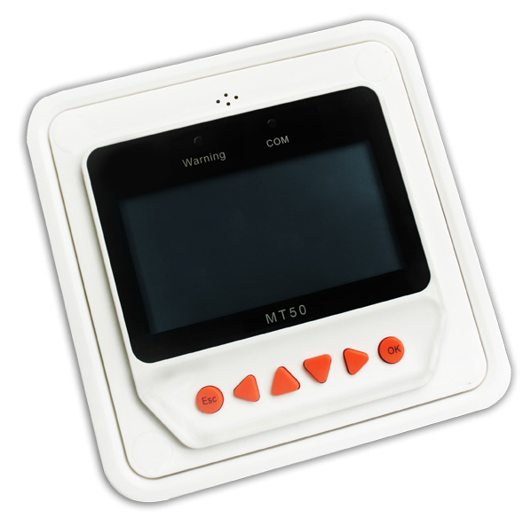

Thank you very much for selecting our product!
This manual offers important information and suggestions with respect to installation, use and troubleshooting, etc. Please read this manual carefully before using the product.

Remote Meter

MT50

Remote meter (Model MT50) is available to connect with solar controllerLSxxxxB, VSxxxxB and TracerxxxxB.

Contents

- Important Safety Instructions 1
- General Information 1
2.1Features 1
2.2Main functions 2
2.3Recommendations 3
- Installation 3
- Product Features 7
4.1Monitoring screen 10
- Operation 11
5.1Buttons 11
5.2Main menu 12
5.3Real-time monitoring 12
5.4Device information 14
5.5Test operation 14
5.6Control parameter 15
5.7Load setting 19
5.8Device parameter 23
5.9Device password 24
5.10Charge mode 24
5.11Factory reset 25
5.12Failure information 25
5.13Meter parameter 26
6 Technical Specifications 27

1 Important Safety Instructions

SAVE THESE INSTRUCTIONS:
This manual contains important safety, installation and operating instructions for the Remote Meter.

General safety information
- Please inspect the MT50 thoroughly after it is delivered. If any damage is seen, please notify the shipping company or our company immediately. A photo of the damage may be helpful.
- Read all instructions and cautions in the manual before starting the installation.
- Keep the MT50 away from rain, exposure, severe dust, vibrations,corrosive gas and intense electromagnetic interference.
- Do not allow water to enter remote meter.
- There are no user serviceable parts inside the controller. Do not disassemble or attempt to repair it.

2 General Information

2.1 Features
The new-generation remote display unit MT50 for LSxxxxB, VSxxxxB and TracerxxxxB controllers is an associated display device which supports both

the latest communication protocol and the voltage technology standard of solar controllers. The products have many excellent functions:
- Automatic identify and display the type, model and relevant parameter
data of controllers;
- Real-time display the operational data and working status of the connection devices in digital, graphic and textual forms by a large-screen multifunction LCD;
- Direct, convenient and rapid operation of six navigation function keys;
- Both data and power flowing on the same lead, no need for external power;
- Real-time data monitoring and remote load switchover of the controllers, and data browse and modification of device parameters, charge control parameters and load control parameters;
- Real-time display and acoustic alarm of failure information of the connection devices;
- Longer communication distance based on RS485.

Main functions
Functions like the real-time monitoring of the operational data and working status of a controller, the browse and modification of charge/discharge control parameters, the setting of device parameters and load control parameters and the restoration of factory defaults, based on LCD display and functional key operation.

Recommendations
- Please confirm that MT50 is only allowed to connect with our LSxxxxB, VSxxxxB and TracerxxxxB series controllers before purchase;
- Please do not install MT50 in a situation with strong electromagnetic
interference.

3 Installation

mm(inches)
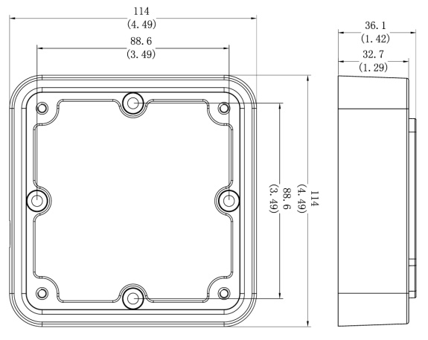

Frame Mount Dimensions

Wall installation steps
Step1: Locate and drill screw holes based on the Frame Mounting dimension of the base, and erect the plastic expansion bolts;

Step 2: Use four ST4.2×32 self-tapping screws to fix the Frame;

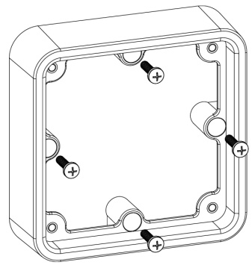
Mechanical  parameter | Parameter
Overall  dimension | 114 x 114 x 32.7mm  4.49 x4.49 x 1.29inches
Mounting  dimension | 88.6x 88.6mm  3.49 x 3.49inches
Terminal | Φ4.3

Frame Mounting

Step 3: Use four M4×8 pan head screws to mount MT50 Surface on the Frame;

Step 4: Mount the four associated screw plugs into the screw holes.

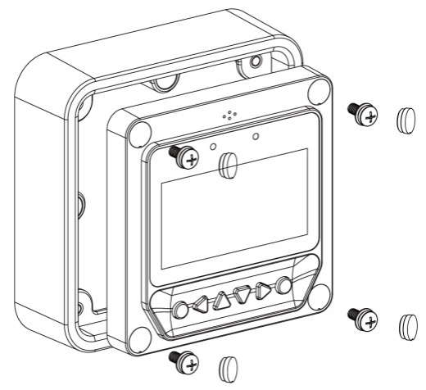

Surface Mounting

Steps of surface mounting:
Step 1: Locate and drill screw holes based on the installation size of the Surface;
Step 2: Use four M4×8 cross recessed pan head screws with M4 nuts to mount MT50 Surface onto the panel;
Step 3: Mount the four associated white screw plugs into the screw holes.
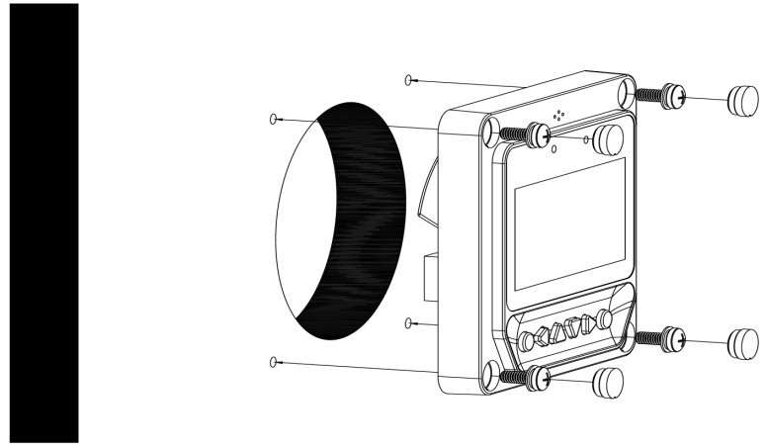Surface mounting

Notice: Take full consideration of the plugging/unplugging space of the communication cable and the length of the cable during installation to see if they are appropriate.

4 Product Features

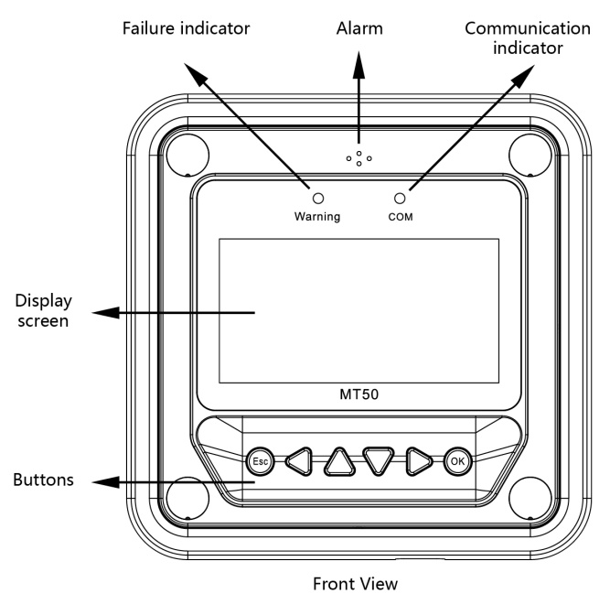

RS485 communication and power interface
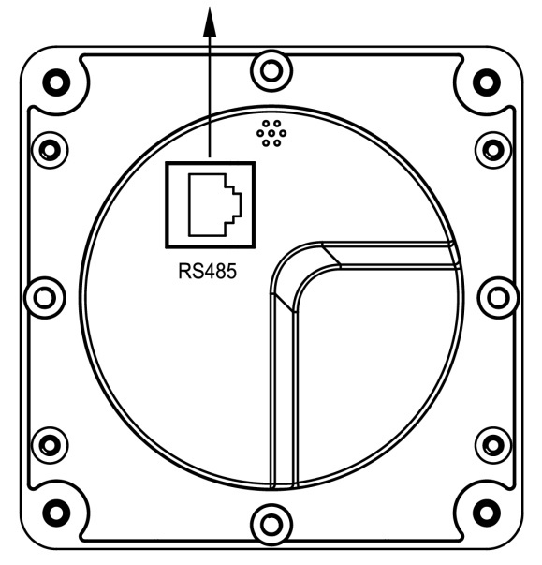
Rear View

Failure indicator
Failure indicator flashes in case of failure of the connection devices. Forfailure information please check the Controller Manual.

Alarm
Fault audible alarm, could be activated or deactivated.

Communication indicator
Indicate communication status when MT50 is connected with the controller.

Display screen
Man-machine interaction operation interface.

Buttons
The Meter buttons includes four navigation buttons and two operational buttons. See the specific directions in the Operational Manual.

RJ45 communication and power interfaces
Communication and power supply cable interfaces, used for communication connection with controllers.

Note: Please use the communication plug which is marked with “MT” to connect MT50

4.1 Monitoring screen

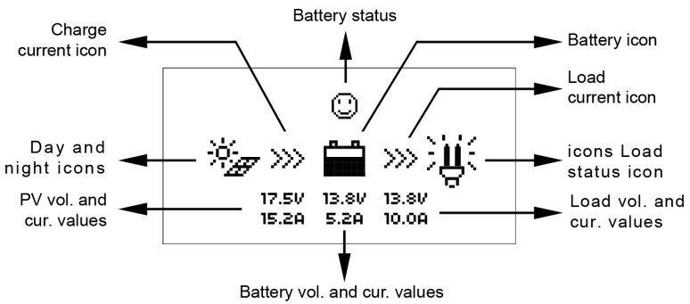

Day and night icons

-Night，- Day: The threshold voltage is 1V. Higher than 1V is daytime.

Charge current icon
The icon is dynamically if there is charge current.

Battery icon
The battery capacity is dynamically displayed based on the SOC value calculated by the controllers.
Note: When the battery is in over discharge status, the icon displayed is“
”.
Battery status icons
-Normal voltage, -Under voltage, -Over discharge.

Load current icon
The icon is dynamically if there is discharge current.

Load status icon
- Load ON, - Load OFF.

5 Operation

5.1 Buttons

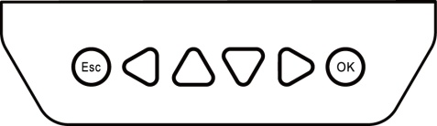
The buttons are respectively (from left to right) “ESC”, “Left”, “Up”, “Down”, “Right” and “OK “buttons, the operation is described in the schematic operation diagram below:
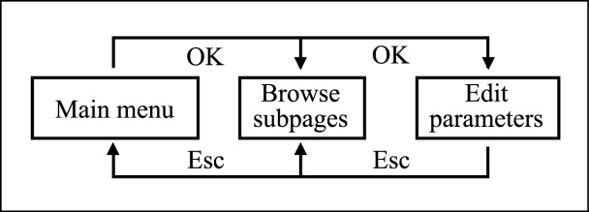

Schematic operation diagram

The default entry page is the browse mode.Pressing button and inputting the correct password to enter the modification mode; and buttons could be used to move the cursor, and buttons could be used to modify the parameter values when the cursor is located at the current place; and buttons could be finally used to respectively confirm and cancel the modification of the control parameters.

5.2 Main menu
“Up” and “Down” buttons are respectively used to move the cursor to select the menu items, “OK” and “ESC” buttons are respectively used to enter or exit the corresponding pages of the menu items.

Monitoring
- Device Info. 3Testoperation 4 Control Para.
- Load set
- Device Para.
- Device PSW 8Charge Mode

- Factory Reset

Failure Info. 11Meter Para.

Real-time monitoring
There are 14 pages under real-time monitoring. Please check it as below:

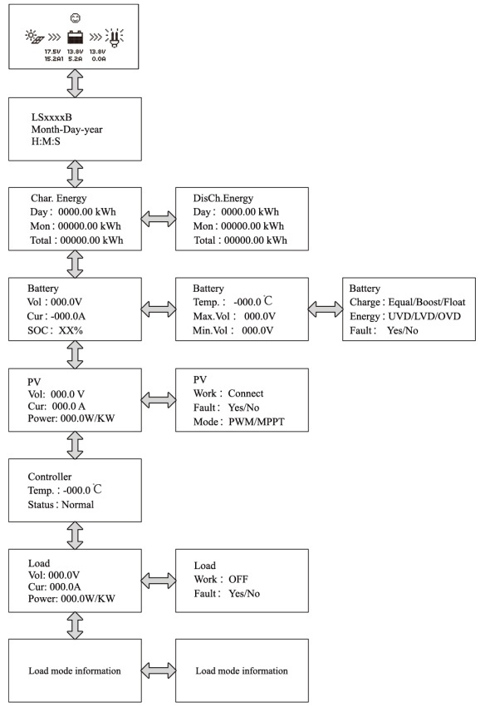
Operational tips: and buttons are respectively used to turn the browse page upward and downward, while and buttons are respectively used to turn the interfaces left and right.

5.4 Device information
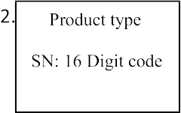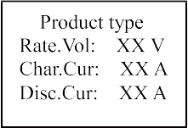The product model, parameters and SN code of the controllers are displayed below:

Operational tips: and buttons are respectively used to turn the browse page upward and downward.

Test operation
Load switch test operation is conducted on the connection solar controller to see if the load output is normal. The test operation does not affect the working settings under actual load, which means that the solar controller will exit from the test modewhen exiting the operational interface of the test.

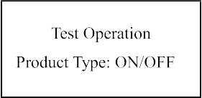

Operational tips: Enter the page and input correct password; use and buttons to modify the ON/OFF status values, while use and buttons respectively to confirm and cancel the test operation.

Control parameter
Browse and modification operations are conducted over the control parameters of solar charge controller. See the scope of parameter
modification in control parameters table, and the page of control parameters
in the diagram below:

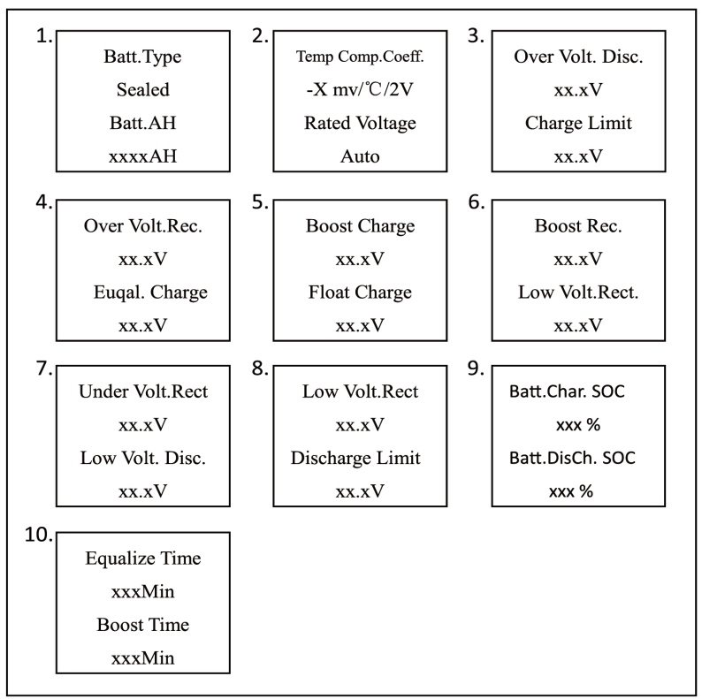

Control parameters table

Control parameters
Parameters | Default | Range
Battery type | Sealed | Sealed/Gel/Flooded/User
Battery Ah | 200Ah | 1~9999Ah
Temperature compensation coefficient | -3mV/℃/2V
Rated voltage | Auto | Auto/12V/24V/36V/48V  Depends on the versions of the controllers
Charging SOC | 100% | Fixed Value
Discharging SOC | 30% | 10~80%

Battery voltage parameters
(Parameters is in 12V system at 25℃ , please use X 2 in 24V, X 3 in 36 V, and X 4 in 48 V system)

Control voltage parameters
Battery charging setting | Gel | Sealed | Flooded | User
Over voltage disconnect voltage | 16.0V | 16.0V | 16.0V | 9~17V
Charging limit voltage | 15.0V | 15.0V | 15.0V | 9~17V
Over voltage reconnect voltage | 15.0V | 15.0V | 15.0V | 9~17V
Equalize charging voltage | —— | 14.6V | 14.8V | 9~17V
Boost charging voltage | 14.2V | 14.4V | 14.6V | 9~17V
Float charging voltage | 13.8V | 13.8V | 13.8V | 9~17V
Boost reconnect charging voltage | 13.2V | 13.2V | 13.2V | 9~17V
Low voltage reconnect voltage | 12.6V | 12.6V | 12.6V | 9~17V
Under voltage  warning reconnect voltage | 12.2V | 12.2V | 12.2V | 9~17V
Under voltage  warning voltage | 12.0V | 12.0V | 12.0V | 9~17V
Low voltage disconnect voltage | 11.1V | 11.1V | 11.1V | 9~17V
Discharging limit voltage | 10.6V | 10.6V | 10.6V | 9~17V
Equalize duration | —— | 2 hrs. | 2 hrs. | 0~3 hrs.
Boost duration | 2 hrs. | 2 hrs. | 2 hrs. | 0~3 hrs.

Note: Battery voltage setting please in strict accordance with:
- Over Voltage Disconnect Voltage > Charging Limit Voltage ≥ Equalize Charging Voltage ≥ Boost Charging Voltage ≥ Float Charging Voltage > Boost Reconnect Charging Voltage;

- Over Voltage Disconnect Voltage > Over Voltage Reconnect Voltage ;

- Low Voltage Reconnect Voltage > Low Voltage Disconnect Voltage ≥ Discharging Limit Voltage;

- Under Voltage Warning Reconnect Voltage > Under Voltage Warning Voltage ≥ Discharging Limit Voltage;

- Boost Reconnect Charging Voltage > Low Voltage Disconnect Voltage.

Load setting
The page of load setting could be used to set the four load working modes of the connection solar controller (Manual, Light on/off, Light on+timer, Time control).

◎Manual Control
◎Light on/off
◎Light on+Timer
◎Time Control

Manual Control Default：ON/OFF

◎Manual Control
◎Light on/off
◎Light on+Timer
◎Time Control
Light on/off on：5.0VDeT：10M oﬀ：4.0VDeT：10M

◎Manual Control
◎Light on/off
◎Light on+Timer
◎Time Control
Light on+Timer on：5.0V DeT：10M oﬀ：4.0V DeT：10M
NightTime:XXH:XXM
Light on+Timer OnTime1 XXH:XXM OnTime2 XXH:XXM

◎Manual Control
◎Light on/off
◎Light on+Timer
◎Time Control
Time Control
■Time1 OnTime H:M:S OﬀTime H:M:S
Time Control
□Time2 OnTime H:M:S OﬀTime H:M:S

- Manual control
Manual control
Mode | Introductions
ON | Load is on all the time if battery capacity is enough and  no abnormal conditions happen.
OFF | Load is OFF all the time.

② Light ON/OFF
Light ON/OFF

Light ON voltage(Night  threshold) | When input voltage of solar module is lower than light ON voltage, it automatically turns ON load output if battery capacity is enough and no abnormal conditions happen.
Light OFF voltage(Day  threshold) | When input voltage of solar module is higher than light OFF voltage, it automatically turns off load output.
Delay time | The confirmation time for Light signal. During the period, if light signal voltage continues  matching Light ON/OFF voltage, it will carry out corresponding actions（The time adjustment range:0~99mins）.

③ Light ON+ timer
Light ON+ timer

Working time 1（T1） | Load working period after light control turns ON load | Any of the working time is set as “0”, it means thistime will  stop working. The real working time of T2 depends on  the Night time, and the length of T1, T2.
Working time 2（T2） | Load working period before light control turns off load
Night time | Total night time controller get from  calculation（≥3h）

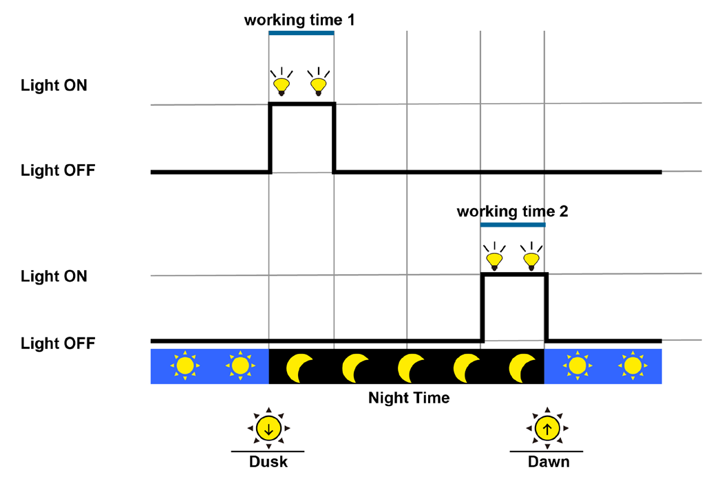
④ Time control
Time control
Working time1  （T1） | Control on/off time of  load through real-time clock mode. | Working time 1 is the  compulsory load working time interval. Working time 2 is an optional.
Working time2  （T2） | Realize the dual timer  function of the load control through  real-time clock mode.

Device parameter
The software version information of solar charge controller could be checked via the page of device parameters, and device data like device ID, device LCD backlight time and device clock could be checked and modified. The page of device parameter in the diagram below:

- 2.
Device Parameter
Ver：VX.XX+VX.XX ID : XXX

Device Parameter Bklight：XXXS Month -Day -Year
H:M:S

Note: the bigger the ID value of the connection device, the longer the Meter
communication identification interval (the maximum interval<6 minutes).

Type | Notes
Ver | Solar charger controller software and hardware version numbers.
ID | Solar charger controller communication ID numbers.
Bklight | Solar charger controller LCD backlight working time.
Month-Day-Year H:M:S | Solar charger controller internal clock.

Device password
The password of the solar charge controller could be modified via the page of device password; the device password is a 6-digit figure which is required before entering the modification mode of “Control parameter”, “Load setting”, “Device parameter”, “Device password”, “Factory reset” pages. The page of device password in the diagram below:

Device PSW OriPSW：XXXXXX NewPSW：XXXXXX

Note: Solar charge controller default password is”000000”

Charge mode
The charge mode of solar charge controller could be selected via the page of charge mode (Voltage Compensate, SOC); the default charge mode is Voltage Compensate charge mode.

Charge Mode Vol.Compen./SOC

Charging mode | Notes
Vol.Compen. | Voltage compensation： Voltage control charging (default)
SOC | By setting the charge and discharge SOC target values for  battery charge and discharge control

Factory reset
The default parameter values of solar charge controller could be restored via the Factory reset page, which means the “Control parameter”, “Load setting”, “Charge mode” and “Device password” of the devices could be restored to the factory defaults (the factory default password of the devices is “000000”).

Factory Reset Yes No

Failure information
The current failure information of the solar charge controller could be checked via the Failure information page (a maximum of 15 failure messages could be displayed); when the failures of solar charge controller are eliminated, the corresponding failure information will also be automatically eliminated.

Failure Info. 1 Over voltage
2 Over load
3 Short circuit

Meter parameter
The meter model, software and hardware version, and SN NO.could be checked via Meter parameterpage. And the three parameters (Switch pages, Backlight, Audiblealarm) could be browsed and modified as well.

    - 1. 2.
Meter Para.
Type：MT50 Ver：Hardware + Software Sn：XXXXXXXXXX

Meter Para. Sw-Pages：XXS BKLight： XXS AudiAlarm：on/off

Note: When the set up is accomplished, the auto switch page cannot become effective until ten minutes later.

Meter parameter
Parameters | Default | Range | Remark
Sw-Pages | 0 | 0~120S | The automatic switchover inverter for real-time  monitoring page
BKlight | 20 | 0~999S | LCD backlight time
AudiAlam | OFF | ON/OFF | Turn ON /OFF the acoustic alarm function in case of failure on solar charge controller

6 Technical Specifications

ELECTRICAL

Electrical parameter
Self-consumption | Backlight and acoustic alarm ON<65mA
 | Backlight ON<23mA
 | Backlight OFF<15mA

MECHANICAL

Mechanical parameter
Faceplate dimensions | 98×98 mm / 3.86×3.86 inches
Frame dimensions | 114×114 mm / 4.49×4.49 inches
Connector type | RJ45
Meter cable | Standard 2m,Max 50 m
Meter weight | Simple package: 0.23 Kg  Standard package:0.32 Kg

ENVIRONMENTAL

Environmental parameter
Ambient temperature | -20℃~+70℃/-4℉~158℉

Definitions of interface pins

Pin No. | Definition
1 | Power+12V input
2 | RS485 B
3 | RS485 A
4 | GND
5 | GND
6 | RS485 A
7 | RS485 B
8 | Power+12V input

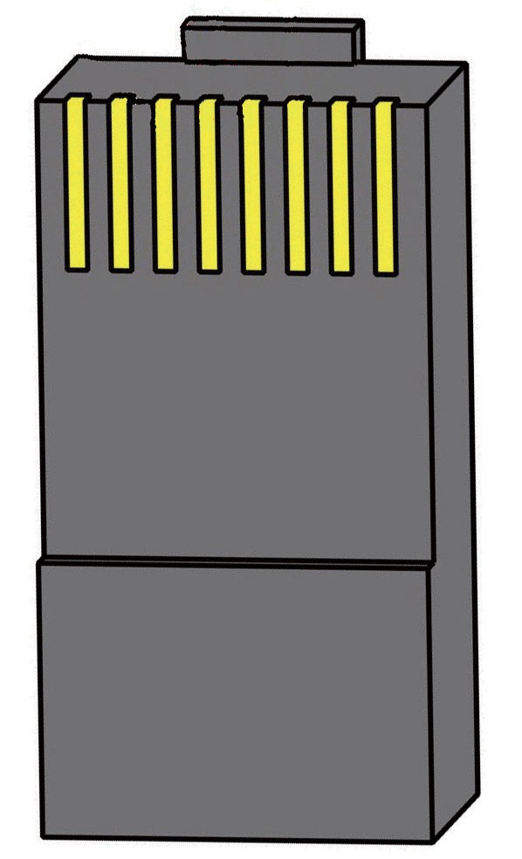Data cable pin definitions

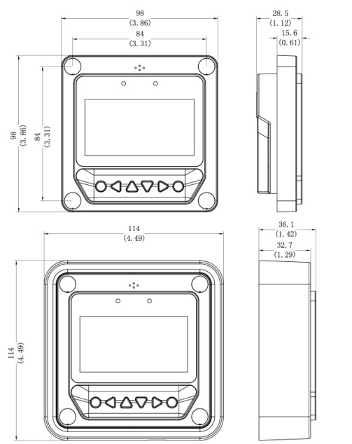
REMOTE METER DIMENSIONS

Ver1.5

BEIJING EPSOLAR TECHNOLOGY CO.,LTD.
Te l : +86-10-82894112 / 82894962
Fax: +86-10-82894882
E-mail: info@epsolarpv.com Website: http://www.epsolarpv.com/

